**Programming Fundamentals-Assignment#01**

**Dr. Sheeraz Arif**

**Fall-24**

**Given Date-05-11-2024 Submission Deadline-23-11-24**

Question: Write the programs of the following problems in c/c++ code:

Note: Also draw flowchart of each of the program and use the comments in coding. Don’t try to cope from google and ChatGPT.

1. Using the increment and decrement operator generate the following output: You can assign integer value 5 in a variable and then apply increment and decrement operator:

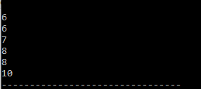

1. Write a program that input the distance between SHU and your home in miles and convert the age into KM, meters, centimeters, millimeters, and micrometers and then print all these computed values on screen.
2. Write a program which takes computes the SGPA of the semester by taking credit hours of the course and grade point (GP) earned by the students of 5 courses with the help of following given formula:

SGPA= sum of (Cr. Hours of the course x GP earned of that course)/total semester Cr.H

1. Write a program to solve the following quadratic equation which is having 3 input variables a, b, c. Assign float values of your choice into a and b variables and take the integer input value at run time in c variables. You have to evaluate the formula two times with – and + values so you have two output values must be saved in x1, and x2 variable.

[Note:] Use the precedence rules for the arithmetic operators’ usage. For square root use built in function sqrt(x) which is available in math.h.

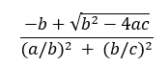

1. Solve the following equation Use the precedence rules for the arithmetic operators’ usage.

A = 7*7*b ( x*y + a ) / c - 0.8 + 2*b *(d)

( x + a )* (1 / y )

1. Write a program to input three integer numbers, compare these three numbers if they are equal. Use “nested if statement” and print the message “All values are equal” if they all are equal. Otherwise print the message “They all are not equal”.
2. Write a program to input a single letter in char variable. if "m" is input print "You are a male" otherwise print "You are a female".
3. Write a program to input marks obtained by a student in a subject. The total marks are 100. Find out the grades of the student by using the ***if else nested*** structure and logical operator. The grades are:
4. if marks are equal to or greater than 90, grade is A+
5. if marks are equal to or greater than 70 and less than 90, grade is A
6. if marks are equal to or greater than 50 and less than 70, grade is B
7. if marks are less than 50, grade is F
8. Write a program using different logical operators together using the following scenario:

{Note: You have to take gender “F”|”M” that must be stored in character variable, age and City name as K|H|S|G as Karachi, Hyderabad, Sukker and GHotki that must be stored in character variable.

1. If gender is female, age is between 25-35 and from Karachi or Hyderabad, add 2000 in the salary and print the net salary.
2. If gender is male, age is between 25-40 and from Sukker or Ghotki, add 2500 in the salary and print the net salary.
3. Otherwise print the present salary no any addition.
4. Write the program code and draw the flowchart of the following given problem:

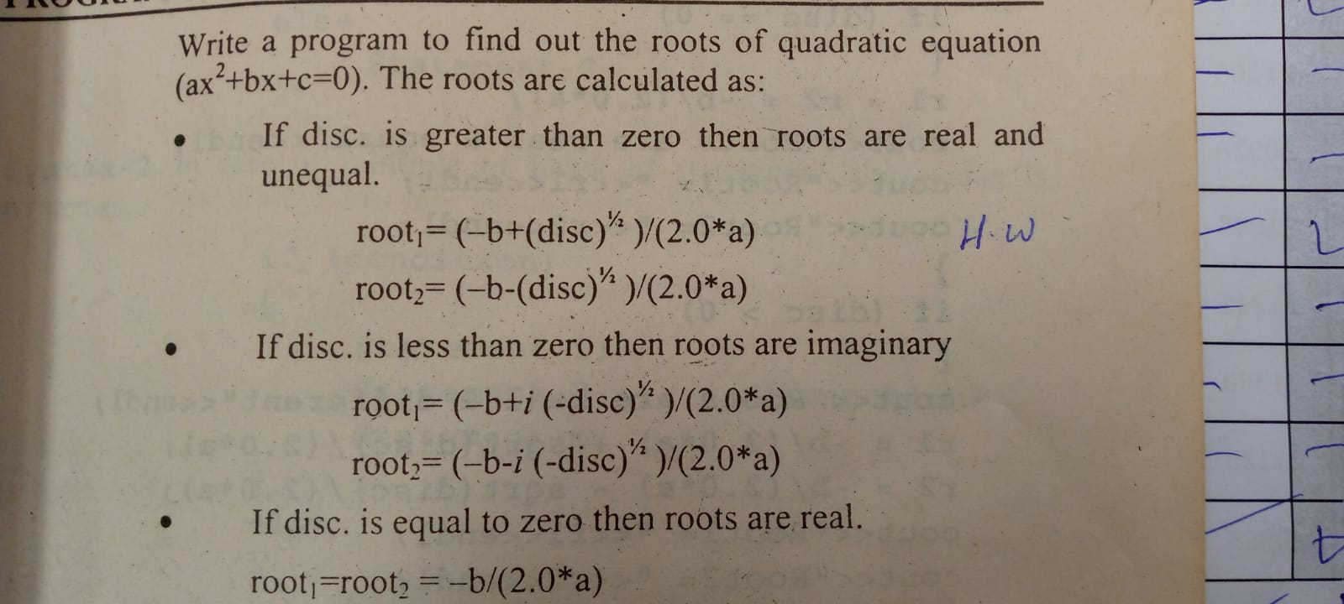

11) Write a program in which user to type his own ID, if the ID is valid it will ask him to enter his password, if the password is correct the program will print the name of the user, otherwise, the program will print Incorrect Password and if the ID does not exist , the program will print Incorrect ID (Solve the problem using nested switch case).

12) Write a program using a “**switch case**” which ask a user to choose a number (1-3) from the display menu to perform the following functions:

* For “1” calculate the square root of that number.
* For “2” calculate the cube of that number.
* For “3” print that number 50 times.
* For “4” print the table of that number
* In the case of none of the above cases, print invalid choice.

13) Using the nested switch case, write a program with a game option with a different hierarchy just for display options to control the game.

14) Write a program to calculate the electricity bill. First, the program takes the current and previous reading as input from a user to compute the total unit consumed of the month. The rates of electricity per unit are as follows:

1. If the units consumed are equal or less than 300, then the cost of a unit is Rs. 4/-per unit and the user will get the subsidy (reduction in bill) of 3% of the gross bill.
2. If units consumed are between 301 to 400, then the cost of a unit is Rs. 6/-per unit.
3. If the units consumed are greater than 400, then the cost of a unit is Rs. 7/-per unit and a surcharge of 4% will be added in the gross bill.

14) Write a program which shows the usage of conditional and all logical operators (OR, AND and NoT)?

15) Using the nested switch case implement the following scenario which shows the department-wise-hierarchy of an organization.

